**Fastlane POC and R&D**

**Fastlane**

*Fastlane* is the easiest way to automate beta deployments and releases for your iOS and Android apps. It handles all tedious tasks, like generating screenshots, dealing with code signing, and releasing your application.

**Requirements:**

1. macOS Sierra 10.12.6
2. XCode
3. iOS Simulator 7 or above

**Installing Fastlane:**

Fastlane can be installed using the following steps:

1. Make sure to have the latest version of the Xcode command line tools installed
2. Install *Fastlane* using

sudo gem install fastlane -NV

when installing on macOS Sierra you may get an error that jwt require ruby 2.1 and above. But Apple ships ruby 2.0 with macOS Sierra. So, if the installation fails you must run this command

sudo gem install -v 1.5.6 jwt

and

sudo gem install fastlane

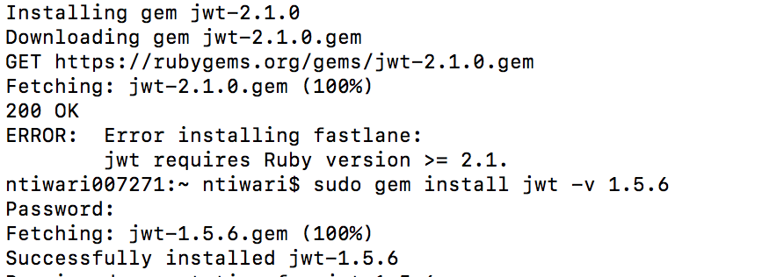

Now navigate(change directory) to your project folder and run below

fastlane init

This command will create the required files and folders.

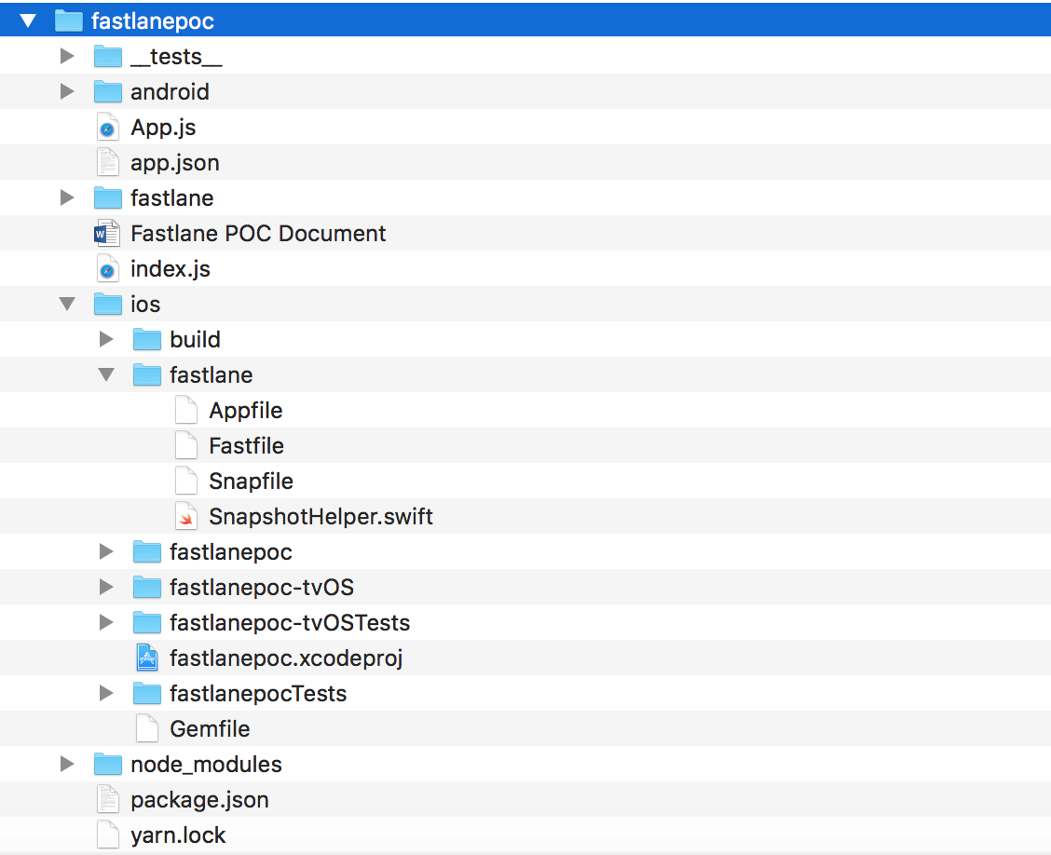

The most important file here is **fastfile**.